A

Technical Seminar on

ROBOTIC PROCESS AUTOMATION

Submitted in partial fulfillment of the requirements for the Award of the degree of

BACHELOR OF TECHNOLOGY IN

INFORMATION TECHNOLOGY

By

V. Vishesh Kumar (16881A12C0)

Under the Guidance of

Dr. Dhana Sree Devi Kunada

Associate Professor

Department of Information Technology



**DEPARTMENT OF INFORMATION TECHNOLOGY**

VARDHAMAN COLLEGE OF ENGINEERING

(AUTONOMOUS)

(Affiliated to JNTUH, Approved by AICTE and Accredited by NBA)

Shamshabad - 501 218, Hyderabad

2016-2020

**VARDHAMAN COLLEGE OF ENGINEERING**

**(AUTONOMOUS)**

**Shamshabad - 501 218, Hyderabad**

**DEPARTMENT OF INFORMATION TECHNOLOGY**



**CERTIFICATE**

This is to certify that the Technical Seminar report entitled as, “ROBOTIC PROCESS AUTOMATION”, done by V. Vishesh Kumar (16881A12C0) Submitted to the department of Information Technology impartial fulfillment of the requirements for the Degree of BACHELOR OF TECHNOLOGY in Information Technology from Vardhaman College of Engineering (AUTONOMOUS), Hyderabad, during the period of 2016-2020. It is certified that he/she has completed the project satisfactorily.

Signature of Supervisor: Head of the Department:

##### Dr. Dhana Sree Devi Kunada Dr. Muni Sekhar Velpuru

Associate Professor, Professor & Head of dept,

Dept. of Information Technology, Dept. of Information Technology,

Vardhaman College of Engineering, Vardhaman College of Engineering,

Hyderabad Hyderabad

## ACKNOWLEDGEMENT

The satisfaction that accompanies the successful completion of the task would be put in complete without the mention of the people who made it possible, whose constant guidance and encouragement crown all the efforts with success.

I wish to express my deep sense of gratitude to **Dr. Dhana Sree Devi Kunada,** Associate Professor, Department of Information Technology, Vardhaman College of Engineering ,for his able guidance and useful suggestions, which helped me in completing the Technical Seminar ,in time.

I am particularly thankful to, **Dr. Muni Sekhar Velpuru,** Professor & Head of Department, Information Technology for his guidance, intense support and encouragement, which helped me to mold my Technical Seminar into a successful one.

I show gratitude to our honorable **Principal Dr. S. Sai Satyanarayana Reddy**, for providing all the facilities and support.

I avail this opportunity to express my deep sense of gratitude and heartfelt thanks to all the members of management, for providing a congenial atmosphere to complete this Technical Seminar successfully.

I also thank all our teaching and non-teaching staff members of the Information Technology department for their valuable support and generous advice. Finally thanks to all our friends and family members for their continuous support and enthusiastic help.

##### V. Vishesh Kumar (16881A12C0)

**VARDHAMAN COLLEGE OF ENGINEERING**

**(AUTONOMOUS)**

##### Shamshabad-501218, Hyderabad

##### DEPARTMENT OF INFORMATION TECHNOLOGY



**DECLARATION**

I V. Vishesh Kumar (16881A12C0), student of Bachelor of Technology in INFORMATION TECHNOLOGY, Vardhaman College of Engineering , Shamshabad , Hyderabad (T.S) hereby declare that this report entitled “ROBOTIC PROCESS AUTOMATION” is a genuine task carried out by me and is correct to the best of our knowledge and has not been submitted to any other course or university for the award of our degree by us.

` Signature of the student: V. Vishesh Kumar(16881A12C0)

Date:

**ABSTRACT**

Robotic process Automation (RPA) is an associate rising type of business process automation technology supporting the notion of software system robots or artificial intelligence (AI) workers. In traditional workflow automation tools, a software developer produces inventory actions to automatism a task and interface to the back-end system exploitation internal application programming interfaces (API) or dedicated scripting language.

In distinction, RPA systems develop the action list by looking at the user performing that task within the application’s graphical user interface (GUI), and then perform the automation by repeating those tasks directly within the GUI. This may lower the barrier to use of automation in products that may not otherwise feature arthropod genus for this purpose.

Business processes are part of the daily routine of every business; they are requested to perform at the best possible way, without any losses. Traditionally, over the time people are trying to automate processes using many techniques that may include machines or mechanical robots. A lot of processes performed in modern business or e-business are done using computers so there is a need to avoid losses caused by bad or slow process performances.

The way of automation of processes using software that will perform like humans and carry out tasks on the computers is referred to as the robotic process automation. Usually, it is used to automate processes of relatively low to middle complexity and high repetitiveness. Business which automated its processes using robotic process automation is supposed to gain multiple benefits in terms of reduced costs, improved process efficiency and significantly reduced number of rework tasks within the process.

**CONTENTS**

**Certificate**

**Abstract**

**List Of Figures**

**1 INTRODUCTION**

**2 WHAT IS ROBOTIC PROCESS AUTOMATION**

**3 WHY RPA**

**4 TOOLS OF ROBOTIC PROCESS AUTOMATION**

**5 TEST AUTOMATION V/S RPA**

**6 APPLICATIONS OF ROBOTIC PROCESS AUTOMATION**

**7 ADVANTAGES**

**8 DISADVANTAGES**

**CONCLUSIONS**

**REFERENCES**

**LIST OF FIGURES**

|  |  |  |  |
| --- | --- | --- | --- |
| **S. No** | **Figure No.** | **Figure Description** | **Page No.** |
| 1 | Figure 3.1 | Process in Business Scenario | 4 |
| 2 | Figure 3.2 | Business Work flow | 4 |
| 3 | Figure 3.3 | Disparate & Multiple IT system can’t map competitive business | 5 |
| 4 | Figure 3.4 | Digital workforce and human workforce with PROCESS and TECHNOLOGY | 6 |

**CHAPTER 1**

**INTRODUCTION**

The robotic process automation (RPA) does not represent neither physical nor mechanical robots, even if it brings to our mind a vision of some electromechanical machine. In the term of robotic process automation, robot refers to a software-based solution, programmed to carry out procedures, processes or tasks in the repetitive way that are usually done by humans.

When individuals initially hear the term “Robotic Process Automation” they could imagine shiny robots sailplaning around workspace buildings. In reality, this can be simply a software package that may be created to perform the kinds of administrative tasks that otherwise need to stop-gap human handling; most operations teams adopting RPA have assured their employees that automation would not result in layoff. Instead, staff is redeployed to try doing a lot of fascinating work. One educational study highlighted that knowledge workers didn’t feel vulnerable by automation: they embraced it and viewed the robots as team-mates. Among different technological trends, is predicted to drive a new wave of productivity and efficiency gains in global labor.

* **Historic Evaluation**

Robotic process automation proves itself as a game changing technology. Yet a very common topic of debate among the automation community is whether RPA is a new development or it should be seen simply as an extension of the technologies that came before it.

For better understanding, we need to study the following three key predecessors of RPA

**1. Screen Scraping Software**

A screen scraping software is meant to scan large sets of static information or other visual representation of data to pull key terms, integers or other important analytics. In the context of RPA, we can say that the same functionality is used by RPA. Even RPA is integrating screen scraping capabilities into a larger suite of functions.

**2.Workflow Automation and Management Tools**

As the name suggests, such tools can help in order processing by capturing customer contact information, invoice total as well as item ordered. They even translate these details into our company database and notify the corresponding employee too. Such tools eliminate manual data entry. In the context of RPA, we can say that the same functionality is used by RPA. Even RPA is integrating its work automation tool capabilities into a larger suite of functions.

**3.Artificial Intelligence**

As we know that AI is the capability of computer systems to perform tasks that normally require human intervention and intelligence. AI machines can replace tedious and manual labor that is time consuming. In the context of RPA, we can say that the same functionality is used by RPA. Even RPA is integrating AI capabilities into a larger suite of functions.

All of the above three advancements in automation were significant in one or other sense but what makes RPA an impactful technology is its ability to combine, refine certain aspects of each of these technologies.

**CHAPTER 2**

**WHAT IS ROBOTIC PROCESS AUTOMATION**

Robotic Process Automation is the technology that allows anyone today to configure computer software, or a “robot” to emulate and integrate the actions of a human interacting within digital systems to execute a business process. RPA robots utilize the user interface to capture data and manipulate applications just like humans do. They interpret, trigger responses and communicate with other systems in order to perform on a vast variety of repetitive tasks.

Robotic Process Automation (RPA) is the technology that allows the automation of the task in exactly the way a human does. A robot in robotic process automation does not mean that literally robots are going to replace human beings, but it means a computer program that imitates human actions.

In other words, we can say that RPA is a software program that imitates human actions while interacting with a computer application and accomplishing the automation of repetitive and rule-based processes. RPA can be used to automate the labour-intensive tasks such as back office processes, data entry, data validation etc.

**CHAPTER 3**

**WHY RPA**

In today's scenario of typical enterprises, RPA can be used to fill the gap between systems and process. A typical enterprise is having the following scenario −

The typical process in business scenario is rapidly changing due to competition, can be understood with the help of following diagram −

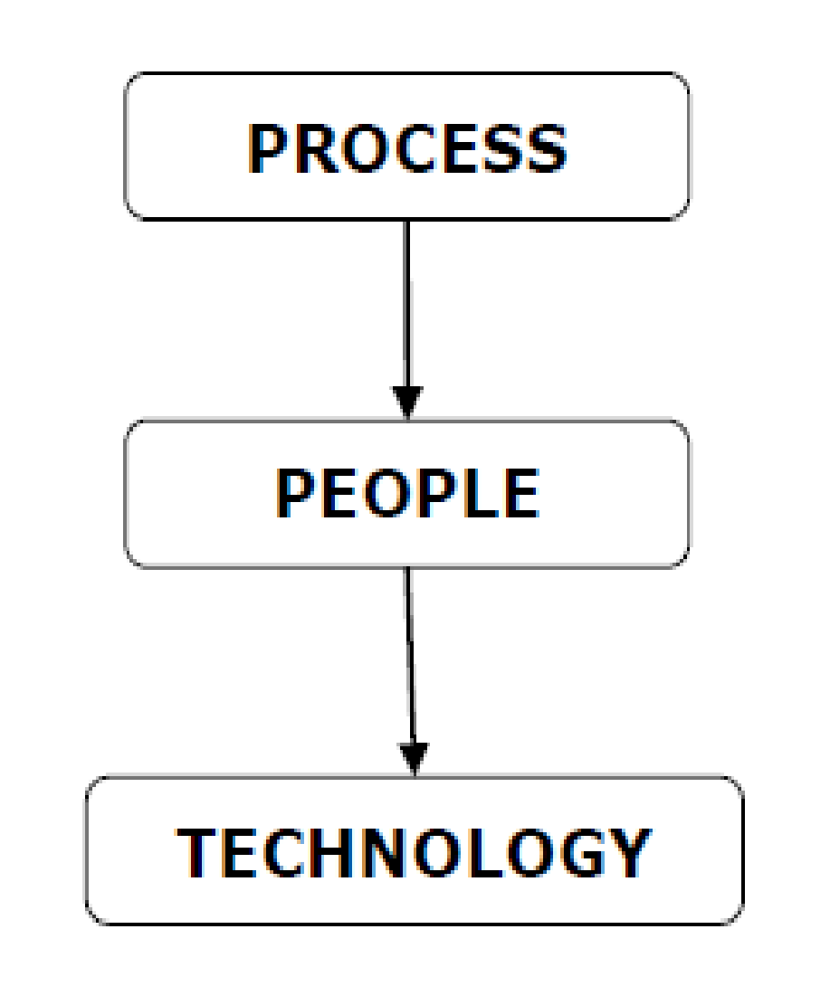

Fig: 3.1 Process in Business Scenario

If we talk about technology in the business scenario, a typical enterprise uses multiple and disconnected IT systems to run its operations. But due to lack of updating, these technical processes cannot help business to the required extent. It can be understood with the help of following diagram



Fig: 3.2 Business Workflow

If we talk about people in business scenario, a typical enterprise hires human workforce to fill

the gap between systems and processes.

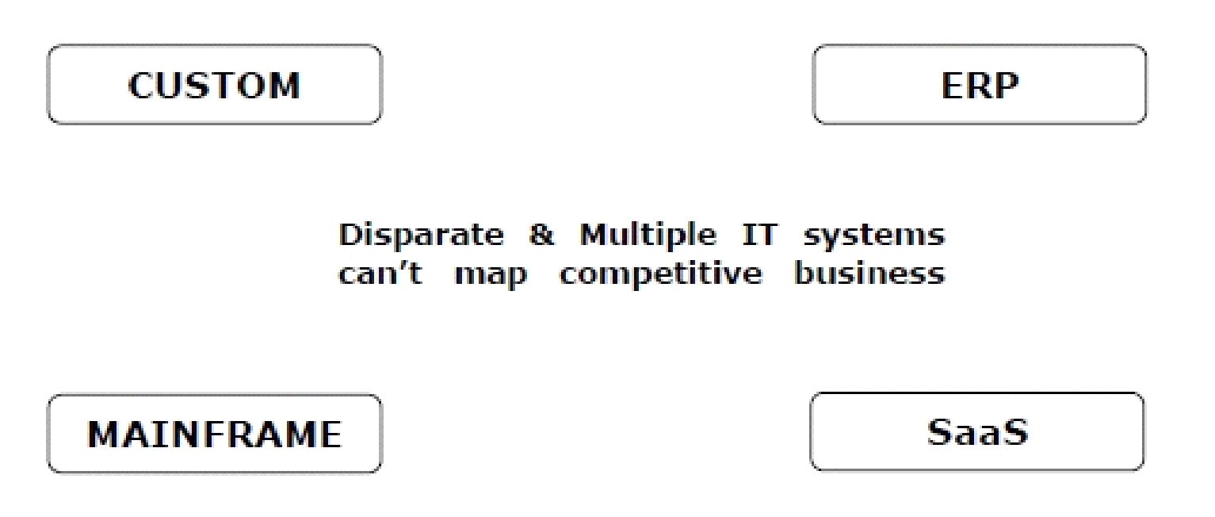

Fig: 3.3 Disparate & Multiple IT system can’t map competitive business

A challenging issue in a business enterprise is change. Why challenging, because with any change in business process, enterprises either need to hire new employees or train its existing ones. Both solutions are costly as well as time consuming.

Another solution is RPA with which company can deploy virtual workers imitating human workers. Now if any change happens, only change in few software code lines would be required which is much cheaper and faster solution than hiring employees. It basically maps digital workforce and human workforce with PROCESS and TECHNOLOGY in a business enterprise.

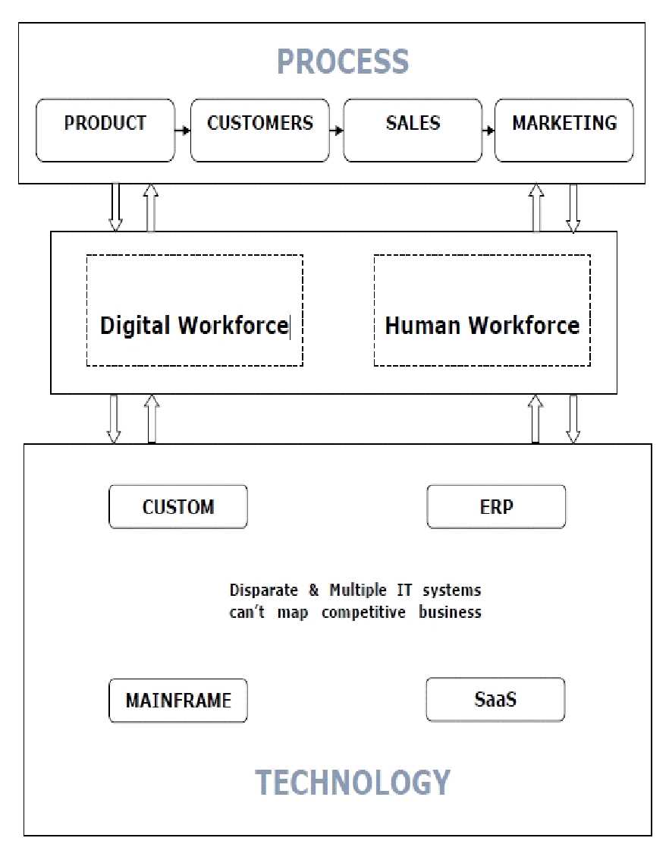

Fig: 3.4 Digital workforce and human workforce with PROCESS and TECHNOLOGY

**CHAPTER 4**

**TOOLS OF ROBOTIC PROCESS AUTOMATION**

Robotic Process Automation (RPA) Tools are widely used for the configuration of task automation. These tools are indispensable for automation of the repetitive back-office processes. There are numerous RPA tools available in the market and choosing one could be a challenge. Following is a curated list of RPA software:

* [**OutSystems**](https://bit.ly/32P4B05)**:**

[OutSystems](https://bit.ly/32P4B05) is the #1 RPA with advanced capabilities for enterprise mobile and web apps.

* **LINX:**

[Linx](https://bit.ly/2K1Lt5o) is a no-code RPA platform that enables the rapid development and deployment of automated processes and tasks. Linx offers a no-code IDE designer that significantly speeds up development and a hosted server - for fast, no fuss, 1-click deployment.

* [**HelpSystems**](https://bit.ly/2mwX82y)**:**

[Automate](https://bit.ly/2mwX82y), by HelpSystems, is a comprehensive RPA platform designed to automate repetitive and manual processes across your organization. Automate provides 5x the value of other solutions through its ease of use, stable and robust functionality, and ability to scale your automation strategy.

* **Automation Anywhere:**

[Automation Anywhere](https://bit.ly/2Yv7w89) RPA developer tool combines conventional RPA with intellectual elements like language understanding and reading any unstructured data.

* **UiPath:**

[UiPath](https://bit.ly/2K31oQR) is a highly extensible Robotic Process Automation (RPA) tool for automating any desktop ors web apps.

**CHAPTER 5**

**TEST AUTOMATION V/S RPA**

Fast release, less time consumption, less cost consumption, correctness and quality assurance are some of the apparent reasons to call RPA and test automation two similar processes.

Some useful parameters which gives the key differences between them are discussed below −

* **Goal** − The main goal of test automation is to reduce test automation time through automation. On the other hand, RPA's goal is to reduce headcounts through automation.
* **Coding skills** − Test automation requires coding skills to create test scripts. RPA is wizard-driven and does not require any coding skills.
* **Implementation** − Test automation can automate a product only. On the other hand, RPA can automate products as well as service.
* **Users** − As discussed test automation requires technical skills, hence it is limited to only technical people; however RPA can be used by non-technical persons too.
* **Application** − Test automation can be run on quality assurance, production and UAT environments, but RPA can usually run only on production environments.
* **Example** − The best example of test automation is automated test cases. On the other hand, the examples of RPA are data entry, forms, loan processing etc.

The above differences prove that RPA is an advanced approach that provides better assistance to test automation.

**CHAPTER 6**

**APPLICATIONS OF ROBOTIC PROCESS AUTOMATION**

**1. Operational activities in sales:**

Just think a moment about the monotonous task of keeping data consistent across CRM and accounting records. Ok, you can now let go of the thought, we don’t want to spoil your mood for the rest of the day. The good news is that **software robots** can handle these operational activities on their own. For instance, automation can make invoices available to customers much faster than manual performance.

A highly desirable effect of this is earlier customer payments, which also improves the cash flow, and consequently - customer satisfaction. More generally, the need for error-free sales operations is justified by the desire to avoid customer complaints and dissatisfaction, which are quite often the result of clerical mistakes.

**2. Procure-to-pay:**

This subdivision of the procurement process can be considered the epitome of inter-department work since it is inherently based on the interaction between the purchasing department and the accounts payable department.

“Automation in a system that is essentially characterised by the integration of various systems?!” Indeed, no need for raised eyebrows. Front-end software robots can actually do this proficiently, thereby ensuring that transactions are well aligned by consistent data.

Below we have a case study of RPA implementation in an Australian FMCG food company, that used software robots to automate payment portal receivables.

**3. Portal queries:**

When automated, this process too leverages the integrative capacity of software robots. Portals are a vital mediator between organizations and suppliers. The plural is crucial in that it highlights the usefulness of data integration. The idea is that bots can be used to link all your portals, providing employees with direct access to compiled data.

**4. Data extraction:**

Data entry is the nightmare of monotony for your employees - we can agree on that, right? Well, even though RPA can't save you of all the trouble, at least it can alleviate it. Because it has the capacity for basic pattern recognition, and because it can convert pretty much any kind of text into editable and searchable machine-encoded text, it drastically reduces the need for manual data entry. Therefore, fewer errors and faster results, therefore less exhausted and bored employees.

**5. Reconciliation:**

The main objective of accounting records reconciliation is that your records be error- and omission-free. By comparison of documents, e.g., the cash book and the bank statement, the procedure is meant to ensure the reliability of the records.

**6. Price comparison:**

Software robots can keep track of fluctuating prices. Given (4) above, bots can automatically extract data for best pricing.

**7. Data management:**

Relevant data comes from a variety of sources - personal records and files, operational performance datasheet, etc. - which ought to be put together and analyzed consistently. Moreover, the end results must be passed on in due time to business executives.

This involves a lot of careful processing, with attention to a plethora of details. For humans, this is time-consuming and nerve-wracking. Software robots, on the other hand, can do it fast, correctly, and without demands for stress bonuses.

**8. Payroll management:**

No one can deny the tediousness of the payroll function, and, to make things even worse, the importance of an error-free process. You would probably not want a face to face meeting with one of your managers who has been paid the salary of a janitor who happens to have the same name.

We detect a skeptical frown on your face as you read: “What about modern payroll software?!” Well, especially if your company relies on legacy systems a lot, embracing up-to-date payroll software might not come so easily. Software robots can then offer a salutary helping hand to automating the process.

**9. Auto-generation of reports:**

Much disliked as they may be, regular reports are necessary for functional businesses, so that both the executives and the lower-level employees can keep track of, and align with what goes on in the company.

Software robots are able not only to put necessary data together in order to prepare these reports but also to circulate them so that they promptly reach everybody. It is not at all hard to see how this might ease the burden of [compliance](https://www.cigen.com.au/cigenblog/how-robotic-process-automation-supports-enterprise-compliance-modernisation), the perfect example of “everybody hates it” kind of necessary activity.

**10. Customer service operations:**

Customer service is one of the most complex activities in a company, so we are certainly not saying that it could be left entirely “on the shoulders” of robots. However, man-machine collaboration might greatly improve customer satisfaction, while at the same time making the task less stressful for your employees.

**CHAPTER 7**

**ADVANTAGES**

Robotic process automation software systems and services are ready to run applications the manner a person's operator would. Supported rules, the work flow operates automatically complicated tasks. RPA brings a full form of advantages like:

* **Continuing service:**

Once it involves running real 24/7 service, software package robots emerge as obvious what they are doing, no need to take breaks while doing tasks.

* **Scalability:**

The processes fixed for one software robot are often enlarged to any number of other robots and conversely, robots are often decommissioned of a process to work on another one.

* **Truthfulness:**

Once allotted tasks, robots are designed to faithfully complete the instructions without failing.

* **Time:**

Whereas it takes years to implement traditional projects with humans, it only takes weeks with robots.

* **Improved Efficiency:**

The wonder of RPA is that it’s designed to alleviate human employees of their repetitive daily tasks. Once technology handles these tasks and workflows, the method runs abundant faster and afterwards works more effectively.

* **Greater Productivity:**When technology does the heavy lifting, as is the case with RPA, output can be considerably increased moreover.

**CHAPTER 8**

**DISADVANTAGES**

**1) Monetary Expense:** Budgetary restrictions are among the most important reasons why businesses do not prefer to implement RPA.

**2) Lack of technical ability:** Many of us believe that in order to leverage robotic process automation, the end user should possess significant technical ability. This thought sometimes holds them back from reaping the various advantages that are accessible to them.

**3) Major Change:** Doping a replacement technology needs modification, however with the proper tool, the impact of that change is much less noticeable and disruptive than many realize.

**4) Redundancy:** Another common concern of these resistant to RPA is that the worry that robots will replace human workers, when its main purpose is to actually support humans within the work typically can’t determine if the person making the inquiry is who they say they are. By analysing unstructured data (e.g. say, reviewing a scanned passport image and matching it against a customer’s account record), machine learning is then able to create a connection between doing and thinking in an automated environment. Typically, can’t determine if the person making the inquiry is who they say they are. By analysing unstructured data (e.g. say, reviewing a scanned passport image and matching it against a customer’s account record), machine learning is then able to create a connection between doing and thinking in an automated environment.

**CONCLUSION**

The automation of business processes using robotic process automation (RPA)can be a very efficient solution for repetitive tasks and for companies facing different transitions, even organizational changes or system changes, since RPA is not a disruptive technology in terms of application in an enterprise. As a trend, it is becoming used by many companies which notice several benefits.

Robotic process automation (RPA) provides advanced software system robots taking the place of humans whenever complicated processes or routine tasks will be machine-controlled. That being said, how will artificial intelligence and connected technologies empower it. As we have a tendency to enter the digital transformation era, our industries are reporting that their task forces are operational regarding eighteenth of their IT processes manually, lowering their performance and motivation. At a similar time, they estimate that a minimum of five hundredth of those tasks may be automatic. RPA uses software packages and methodologies that are capable of taking advantage of the most recent technologies together with artificial intelligence, machine learning, voice recognition, and linguistic communication processes to require automation to future level. That creates it a requirement for corporations of all industries that wish to convey their business right along the digital transformation journey.

**REFERENCE**

[1] Albus, J.S., C.R. Mclean and M.L. Fitzgerald,” hierarchical control for robots in automated factory”, robots,7,1983.

[2] Dutta, A.K.,’Sensor systems for robotic’, Ph.D. Thesis, Jadavpur univ. Calcutta 1990.

[4] Rosen, C.A. and D. Nitzan,” uses of sensors in programmable automation”, computer, IEEE, December ,1977s.

[5] Paul Roy, Peter Dickinsion,” How Robotic Process Automation and Artificial Intelligence will Change Outsourcing” Seminar on June 7, 2016.

[6] Paul Roy, Peter Dickinsion, “How Robotic Process Automation and Artificial Intelligence will Change Outsourcing” Seminar on June 7, 2016.

[7] Andrew Burgess,” Robotic Process Automation & Artificial Intelligence” handbook posted on 7th June ,2017.

[8] “INTRODUCTION TO ROBOTIC PROCESS AUTOMATION” Institute for robotic process automation and artificial intelligence, June 2015.